Generation of Three Address Code (TAC) for an Arithmetic Expression

AIM:
To write a C program to generate Three Address Code (TAC) for a given arithmetic expression using stacks and operator precedence.

ALGORITHM:
- Start the program.
- Initialize an operator stack and an operand stack.
- Read the input arithmetic expression.
- Separate the target variable from the expression using =.
- Scan the expression from left to right.
- If an operand is found, push it onto the operand stack.
- If ( is found, push it onto the operator stack.
- If ) is found, process operators until ( is encountered.
- If an operator (+, -, *, /) is found:
  - Compare its precedence with the operator at the top of the stack.
  - Process higher or equal precedence operators first.
  - Push the current operator onto the stack.
- After scanning the complete expression, process all remaining operators.
- Generate temporary variables such as t1, t2, etc.
- Assign the final temporary result to the target variable.
- Display the generated Three Address Code.
- Stop.

PSEUDOCODE:

START
Initialize operator stack
Initialize operand stack
Initialize temporary variable count = 1

Read expression
Separate target variable from RHS expression

FOR each character in expression

IF character is space
Skip it

ELSE IF character is operand
Read complete operand
Push operand into operand stack

ELSE IF character is '('
Push '(' into operator stack

ELSE IF character is ')'
WHILE top of operator stack is not '('
Pop operator
Pop right operand
Pop left operand
Create temporary variable
Generate TAC
Push temporary variable
END WHILE
Pop '('

ELSE IF character is an operator
WHILE top operator has higher or equal precedence
Pop operator
Pop right operand
Pop left operand
Create temporary variable
Generate TAC
Push temporary variable
END WHILE
Push current operator

END FOR
WHILE operator stack is not empty
Pop operator
Pop right operand
Pop left operand
Create temporary variable
Generate TAC
Push temporary variable
END WHILE

Pop final result
Assign final result to target variable

Display TAC

STOP

PROGRAM:

#include <stdio.h>
#include <stdlib.h>
#include <ctype.h>
#include <string.h>

#define MAX 100

char opStack[MAX];
int opTop = -1;

char *valStack[MAX];
int valTop = -1;

int tempCount = 1;

void pushOp(char ch)
{
if (opTop < MAX - 1)
opStack[++opTop] = ch;
}

char popOp()
{
if (opTop >= 0)
return opStack[opTop--];

return '\0';
}

char peekOp()
{
if (opTop >= 0)
return opStack[opTop];

return '\0';
}

void pushVal(char *val)
{
if (valTop < MAX - 1)
valStack[++valTop] = strdup(val);
}

char *popVal()
{
if (valTop >= 0)
return valStack[valTop--];

return NULL;
}

int precedence(char op)
{
if (op == '+' || op == '-')
return 1;

if (op == '*' || op == '/')
return 2;

return 0;
}

void processOperator()
{
char op = popOp();

char *right = popVal();
char *left = popVal();

char *temp = (char *)malloc(10 * sizeof(char));

sprintf(temp, "t%d", tempCount++);

printf("%s = %s %c %s\n",
temp, left, op, right);

pushVal(temp);

free(left);
free(right);
}

void generateTAC(char *expr)
{
int i = 0;

char target[MAX] = "";
int targetIdx = 0;

while (expr[i] != '=' && expr[i] != '\0')
{
if (!isspace(expr[i]))
target[targetIdx++] = expr[i];

i++;
}

target[targetIdx] = '\0';

if (expr[i] == '=')
{
i++;
}
else
{
i = 0;
target[0] = '\0';
}

printf("\nThree Address Code (TAC):\n");
printf("-------------------------\n");

while (expr[i] != '\0')
{
if (isspace(expr[i]))
{
i++;
continue;
}

if (isalnum(expr[i]))
{
char operand[MAX];
int k = 0;

while (isalnum(expr[i]))
{
operand[k++] = expr[i++];
}

operand[k] = '\0';

pushVal(operand);
}

else if (expr[i] == '(')
{
pushOp(expr[i]);
i++;
}

else if (expr[i] == ')')
{
while (opTop >= 0 && peekOp() != '(')
{
processOperator();
}

popOp();
i++;
}

else if (expr[i] == '+' ||
expr[i] == '-' ||
expr[i] == '*' ||
expr[i] == '/')
{
while (opTop >= 0 &&
precedence(peekOp()) >= precedence(expr[i]))
{
processOperator();
}

pushOp(expr[i]);
i++;
}

else
{
i++;
}
}

while (opTop >= 0)
{
processOperator();
}

char *finalRes = popVal();

if (target[0] != '\0' && finalRes != NULL)
{
printf("%s = %s\n", target, finalRes);
}

if (finalRes)
free(finalRes);
}

int main()
{
char expr[MAX] = "a = b * c + d";

printf("Input Expression: %s\n", expr);

generateTAC(expr);

return 0;
}

OUTPUT:
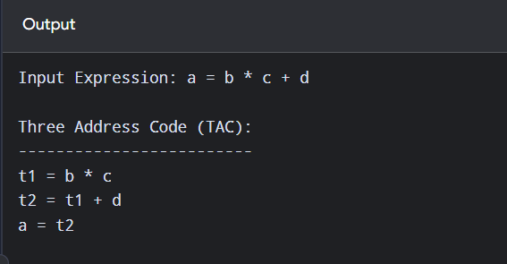

RESULT:
Thus, the Three Address Code (TAC) for the given arithmetic expression was successfully generated using operator and operand stacks.

